**The analyst’s dilemma — too much data, too little time**

**How to resolve it with augmented analytics**

For digital-first businesses, the only way to observe and understand their customers and business is through data. And one would think that with the abundant data, companies have at hand, data-driven decisions would be simple. But data has not only increased in size but also in complexity. Nowadays companies collect many data points on every customer touch point, interaction, sale, etc. So analysis can quickly become a daunting and unfruitful task with traditional BI tools. The good news is, there are also easier tools and processes to facilitate data transformation and visualization. However, the adoption level for these augmented analytics tools/ methods (aka diagnostic analytics powered by machine learning)are still very low.

**Why should you care about augmented analytics?**

The way that we produce and accumulate data and the limitation of human attention create a big dilemma for analysts — too much data and too little time. To create value and business impact from data, teams need to deliver comprehensive actionable insights at the speed of business. However, given the new context and legacy BI tools, most teams end up trading off between:

* **Speed** — not getting answers fast enough to make effective and timely decisions
* **Comprehensiveness** — missing out on insights as they are just scratching the surface and looking through data at a granular level.

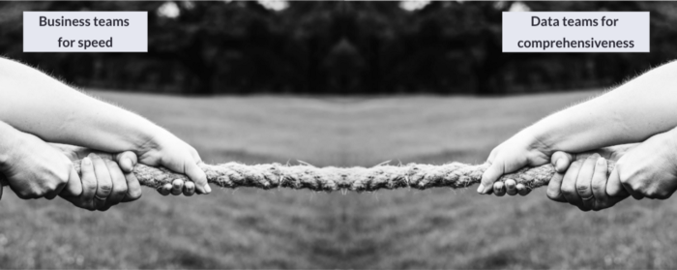

Image by rawpixel.com on Freepik

As a result, actionability suffers. The answers gathered aren’t real insights or the insights aren’t uncovered fast enough to drive business action.

To make this more concrete, let’s take a closer look at the current analytical challenges:

1. **Limited human attention**

I hear these very often:

“There’s so much data and so many metrics, we can’t possibly monitor them all”.

“I have to sift through 15 dashboards every day to assess whether it’s business as usual”

“It would take us days to go through our tools and answer why in a comprehensive way”



Visual created using memegenerator

Data storage and transformation capabilities are not the bottlenecks anymore. However, we’ve been using the same interface for business intelligence — dashboards. As elegantly put by *Herbert A. Simon, t*he current limitation is human attention*:*

“In an information-rich world, the wealth of information means a dearth of something else: a scarcity of whatever it is that information consumes. What information consumes is rather obvious: the attention of its recipients. Hence a wealth of information creates a poverty of attention and a need to allocate that attention efficiently among the overabundance of information sources that might consume it”

As dashboards are unable to direct our attention to where it matters the most, many teams only analyze a portion of the available data, which is one of the most common bad analytics practices ([read the article to find out the other 5](https://towardsdatascience.com/breaking-6-analytics-habits-to-unlock-value-d33fec9c90ee)).

**2. Fast-changing context**

Businesses change faster than ever. As a result, metrics change faster than our ability to explain why using traditional dashboards-based workflows. At the same time, companies need to embrace agile decision-making to stay ahead of the competition.

As Dave Girouard stated:

“Speed is the ultimate weapon in business. All else being equal, the fastest company in any market will win.”

**Why dashboards fall short in solving the analyst’ dilemma**

Dashboards are great for descriptive analytics (i.e., understanding what’s happening) and metrics monitoring. They also enable high-level exploration to identify main trends over time. However, they fall short in diagnostic analytics (i.e., why did it happen).

**Missed opportunities**

As a result of dashboard-based workflows, businesses are missing out on opportunities, given that decision-making is:

* **Reactive —** when something changes, business teams ask the data team to look into it or build ad-hoc dashboards. Teams are reacting to changes.
* **Slow** — ticket loops between data and business teams make diagnostic analytics very slow. In addition, performing root-cause analysis in dashboards is very time-consuming.
* **Poorly informed** — teams often just scratch the surface testing for just a few scenarios overlooking most, as dashboards don’t enable comprehensive root-cause analyses.

**The role of AI and ML**

Machines are great at performing repetitive tasks and computations at scales. In fact, [across many domains, AI is not anymore perceived as a way to compete with workers, but rather to supercharge them.](https://www.wired.com/story/ai-shouldnt-compete-with-workers-it-should-supercharge-them-turing-trap/)

Machines can easily analyze millions of hypotheses in real time, eliminating repetitive slicing and dicing work that keeps teams waiting for insights. By running statistical tests and bringing an impact-focused view, AI and ML can eliminate human bias and point humans’ attention to what’s relevant.

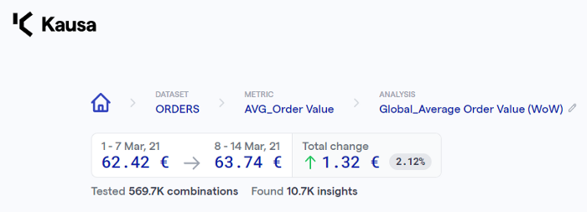

Image by Kausa — machines can test these many combinations and filter out what’s relevant

In the example below, augmented analytics can show that one specific marketing campaign (across hundreds) in Germany is driving a significant increase in AOV for younger customers. Finding these insights in a manual way is like looking for a needle in a haystack.

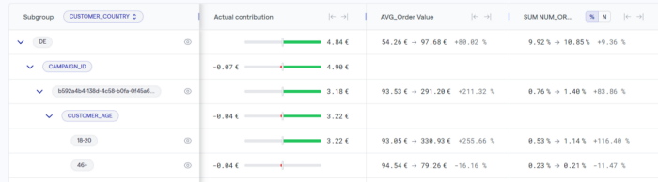

*Image by Kausa — priotization of drivers by impact*

However, machines don’t have the context to interpret the data, connect the dots with what’s going on in the business, and share insights. Who can close this gap? Humans. They are the ones who can look at the relevant information, filter what’s relevant, and connect the dots to drive action.

**Human-in-the-loop proactive analytics**

*Most data scientists overestimate the ability of AI and ML and underestimate the importance of context and domain expertise.*

Machines can run statistical tests and compute many numbers in seconds. However, they can’t (yet) interpret the results and connect the dots to what’s happening in the business (e.g., actions taken, seasonality, external factors, etc). Humans should decide which insights to focus on, communicate them effectively, and drive action to complete the last mile of analytics.

**Where do you stand?**

There are multiple applications and benefits of augmented analytics depending on the specific business use case. These can be segmented based on two key dimensions:

* *Speed* — how fast-changing is the environment and how often are decisions made. For instance, performance marketing is often very fast-changing, as marketing managers take action almost every single day to tweak campaigns/bids and optimize marketing spend. On the other hand, product feature decisions are typically few and data analyses can take longer.
* *Complexity* — number of relevant dimensions and related metrics. Some use cases are by nature very complex since they encompass a high number of relevant dimensions and related metrics. For instance, in-game optimization involves very wide and complex datasets, given the high number of events stored. On the other hand, a marketing manager only running a couple of campaigns in a specific channel and country manages very little complexity.

Based on these elements, one can group use cases into the following matrix, basing the names on what it feels like to work on them with traditional approaches.

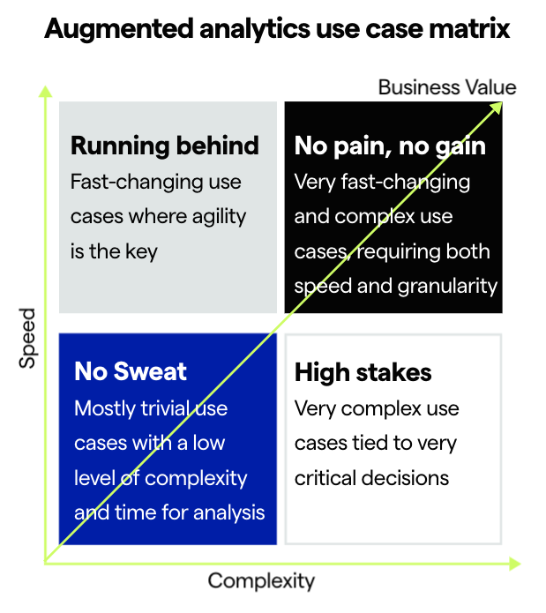

Use cases matrix — developed by the author

**1) No sweat**

These use cases are relatively trivial (i.e., a low number of relevant dimensions and relevant metrics). Teams deal with a low level of complexity and have significant time for data analysis.

An example could be a small e-commerce company operating in a single region and running a couple of marketing campaigns. Actions are taken on a monthly or quarterly basis and it’s a slow-moving market.

Most likely traditional BI tools are sufficient for this low level of complexity and slow business dynamic, without making the team sweat.

**2) Running behind**

These use cases are very fast-changing and agility is key. Teams need to make decisions every single day or week. Thus stakeholders need quick comprehensive insights.

A typical use case I’m very familiar with is performance marketing/user acquisition. Oftentimes small teams run many campaigns across various countries, channels, media sources, and platforms, targeting multiple audiences with various messages and creatives. They are trying to optimize ROAS (Return on Ad Spend), by identifying what is working and what is not, fast.

*Application:* Augmented analytics platforms can test every hypothesis in the data and point out which are the most significant subpopulations. This enables teams to quickly identify what’s moving the needle and then understand WHY by looking at related metrics (e.g., CPI increase in iOS campaigns from Vungle in the USA).

*Outcome:* Campaign performance is understood in minutes rather than hours or days, and time saved is reallocated to creative and strategic work.

**3) No pain, no gain**

These use cases are very fast-changing and complex. Teams need to make decisions every day or week. They are under a lot of pressure as there are many potentially relevant dimensions and related metrics to test for at the same time. Using traditional methodologies, they are regularly in fire-fighting mode and need to spend significant time to reach real insights, but their work is usually underappreciated as the analysis takes too long. This bucket corresponds to the hardest use cases such as leveraging game data to shape features, drive engagement and retention, or balance game economy.

*Application: This group does not have the luxury to compromise between speed and comprehensiveness. And they can actually make the most out of automation. They can use augmented analytics to identify where to drill down within minutes and uncover potential opportunities in a proactive manner.*

*Outcome:* With the exploratory analysis uncovering where to look and ensuring teams get actionable insights at the speed of business, the tables will turn. They will transition from a state where they are almost harassed by requests, to trusted advisors anticipating where to focus for the business teams.

**4) High-stakes**

These use cases are very complex, requiring lots of data points, and interactions to be analyzed and tied to big decisions.

A potential use case could be web analytics or supporting product development in gaming. While you don’t want to make changes to your website or to a game level every day due to implementation times, the changes you make are critical for business performance. Before the teams move on with these decisions very complex data with a very high number of variables are collected. Compared to the “no pain, no gain” use case, teams working on these cases have a bit more breathing room due to the slower pace but are still under a lot of pressure due to the high stakes. Due to the complexity of data, even with the slower pace, they are only able to test for the usual suspect, leaving true opportunity discovery to the luck of the draw.

*Application:* Augmented analytics platforms enable teams to leverage every data point by combining multiple sources to uncover actionable insights. Going through this analysis way faster, the team will have time to go beyond just the peaks and drops and can also investigate interesting insights that can help inform the strategy.

*Outcome:* Granular and actionable insights will lead to high-value decisions and improved metrics. By looking into every scenario and not letting any opportunity go wasted, teams will have more confidence to inform these critical decisions and will get a seat at the decision-making table.

**Augmented analytics is the solution**

Augmented analytics brings together technologies (such as machine learning), processes, and people, to help humans leverage the speed and power of machine scale while incorporating their own process and context to make better decisions — at speed and scale. This is the way to close the [diagnostic analytics gap](https://towardsdatascience.com/the-diagnostic-analytics-gap-3f9d0a44e8f8).

—

*Thoughts? Reach out to* [*João Sousa*](https://www.linkedin.com/in/joaoantoniosousa/), *Director of Growth at* [*Kausa*](http://www.kausa.ai/)*. Stay tuned for more posts on how to nail diagnostic analytics and increase the value of data.*